**ZEIDAN PROJECT WEAR**

# INVOICE

## # 1

Bill To:

**SMKN 5 BATAM**

Date:

Oct 25, 2020

Item

Amount

Quantity Rate

**Baju dan Celana Pramuka Putra** 753 IDR 225,000.00 IDR 169,425,000.00

**Balance Due: IDR 236,025,000.00**

**Baju dan Rok Pramuka Putri** 296 IDR 225,000.00 IDR 66,600,000.00

Subtotal: Tax (0%):

Total:



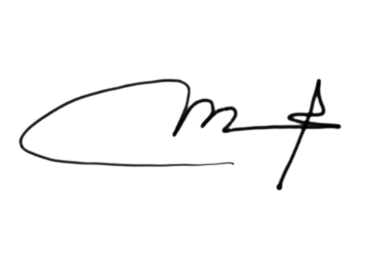

IDR 236,025,000.00

IDR 0.00

IDR 236,025,000.00

|  |
| --- |
| **Mustajib**  **(Bagian Pemasaran)** |

**KERAJINAN KULIT AVIN**

# INVOICE

## # 2

Bill To:

**SMKN 5 BATAM**

Date:

Oct 25, 2020

Item

Amount

Quantity Rate

**Sepatu PDH Putra** 804 IDR 245,000.00 IDR 196,980,000.00

**Balance Due: IDR 268,275,000.00**

**Sepatu PDH Putri** 291 IDR 245,000.00 IDR 71,295,000.00

Subtotal: Tax (0%):

Total:

|  |
| --- |
| C:\Users\LENO\AppData\Local\Microsoft\Windows\INetCache\Content.Word\photo1647068915-removebg-preview.pngMustajib  (Bagian Pemasaran) |



IDR 268,275,000.00

IDR 0.00

IDR 268,275,000.00

**A-GRINA COLLECTION**

# INVOICE

## # 3

Bill To:

**SMKN 5 BATAM**

Date:

Oct 25, 2020

Item

Amount

Quantity Rate

**Kaos dan Training Olahraga Putra** 844 IDR 220,000.00 IDR 185,680,000.00

**Balance Due: IDR 249,040,000.00**

**Kaos dan Training Olahraga Putri** 288 IDR 220,000.00 IDR 63,360,000.00

Subtotal: Tax (0%):

Total:

|  |
| --- |
| **Mustajib**  **(Bagian Pemasaran)** |





IDR 249,040,000.00

IDR 0.00

IDR 249,040,000.00

**SRIWIJAYA INDONESIA**

# INVOICE

## # 4

Bill To:

**SMKN 5 BATAM**

Date:

Oct 25, 2020

Item

Amount

Quantity Rate

**Ikat Pinggang** 1200 IDR 42,500.00 IDR 51,000,000.00

**Balance Due: IDR 51,000,000.00**

Subtotal: Tax (0%):

Total:

|  |
| --- |
| **Mustajib**  **(Bagian Pemasaran)** |



IDR 51,000,000.00

IDR 0.00

IDR 51,000,000.00